**Computing Fundamentals & Programming**

***Section*: BSCE2021 Assignment # 10 *Total marks*: 100**

***Name*** : Muhammad Abubakar Saif

***Roll number* : BSCE21017**



***Submission:***

• *Email instructor or TA if there are any questions. You cannot look at others’ solution or use others’ solution, however, you can discuss it with each other. Plagiarism will lead to a straight zero with additional consequences as well.*

*• Submission after due time will not be accepted.*

**TASKS:**

1. Write code to print “I will be working hard to get a good grade in this course”.

**Code:**

**void** task1() { *//modification is done in "task7" function*

cout << **"I will be working hard to get a good grade in this course"** << endl;

**return**;

}

Output:

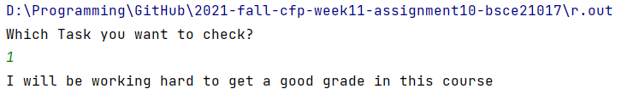

2. Declare 3 variables a,b,c. Take values of these variables from the user as input, and print these values.

**Code:**

**void task2() {**

**int a, b, c;**

**cout << "Enter value for first variable: ";**

**cin >> a;**

**cout << "Enter value for second variable: ";**

**cin >> b;**

**cout << "Enter value for third variable: ";**

**cin >> c;**

**cout << "First variable: " << a << endl << "Second variable: " << b << endl << "Third variable: " << c << endl;**

**return;**

**}**

Output:

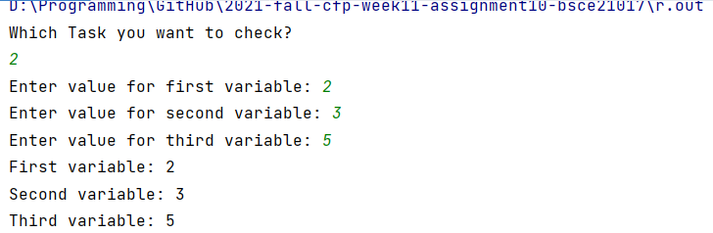

3. Write a function ‘addition’ that takes previously declared variables as parameters and return their sum.

**Code:**

**int** addition(**int** first , **int** second ) { *//int type function takes two parameter of int type,default values = 0*

**int** sum = first + second; *//adds "first" and "second" variables and saves the result in "sum" variable*

**return** sum; *//return the value of sum to the function*

}

Output:

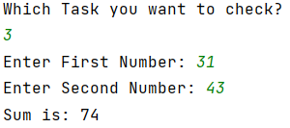

4. Comment on each line of the function in task 3.

**int** addition(**int** first , **int** second ) { *//int type function takes two parameter of int type*

**int** sum = first + second; *//adds "first" and "second" variables and saves the result in "sum" variable*

**return** sum; *//return the value of sum to the function*

}

Output:

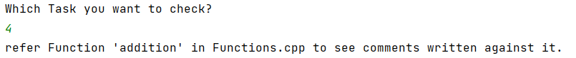

5. Modify your code of task 3, such that it takes default value ‘0’ as parameter values if any of the argument value is not specified.

**Code:**

**int** addition(**int** first = 0 , **int** second = 0) { *//int type function takes two parameter of int type,default values = 0*

**int** sum = first + second; *//adds "first" and "second" variables and saves the result in "sum" variable*

**return** sum; *//return the value of sum to the function*

}

Output:

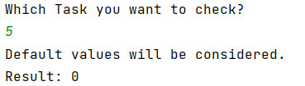

6. Modify your code of task 3, so that same function can be used for any data type. (Hint: Template function).

**Code:**

**template<typename T>**

***//task 6 (modification of Task 3 as asked)***

**T mAddition(T first = 0, T second = 0) { *//T type function takes two parameter of T type,default values = 0***

**T sum = first + second; *//adds "first" and "second" variables and saves the result in "sum" variable***

**return sum; *//return the value of sum to the function***

**}**

**template<typename T1>**

***// to take input from user of any data type***

**void input(T1 &a, T1 &b) {**

**cout << "Enter first input: ";**

**cin >> a;**

**cout << "Enter second input: ";**

**cin >> b;**

**}**

**void helperTask6() { *//calls the function "addition" with different data types***

**int type_choose, first_int, second_int, sum;**

**double first_double, second_double, result;**

**float first_float, second_float, float_result;**

**string first_str, second_str, str_result;**

**again:**

**cout << "Press 1 for 'int'" << endl;**

**cout << "Press 2 for 'double'" << endl;**

**cout << "Press 3 for 'float'" << endl;**

**cout << "Press 4 for 'string'" << endl;**

**cout << "Choose by which 'data type' you want to proceed: ";**

**cin >> type_choose;**

**if (type_choose >= 0 && type_choose < 5) {**

**switch (type_choose) {**

**case 1:**

**input<int>(first_int, second_int);**

**sum = mAddition<int>(first_int, second_int);**

**cout << "Result is " << sum << endl;**

**break;**

**case 2:**

**input<double>(first_double, second_double);**

**result = mAddition<double>(first_double, second_double);**

**cout << "Result is " << result << endl;**

**break;**

**case 3:**

**input<float>(first_float, second_float);**

**float_result = mAddition<float>(first_float, second_float);**

**cout << "Result is " << float_result << endl;**

**break;**

**case 4:**

**input<string>(first_str, second_str);**

**str_result = mAddition<string>(first_str, second_str);**

**cout << "Result is " << str_result << endl;**

**break;**

**}**

**}else {**

**cout << "Invalid Selection, Try again" << endl;**

**Beep(300, 800); *// 1000 hertz for 1 second***

**goto again;**

**}**

**return;**

**}**

Output:

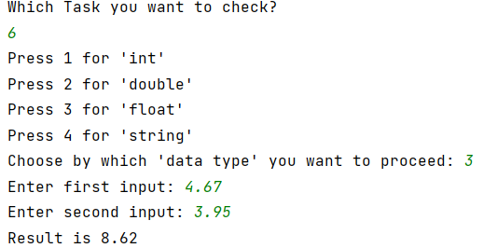

7. Modify your code of task 1 and print “I will be working hard to get a good grade in this course” 1000 times.

**Code:**

**void** task7() { *//modification in task 1 to print given string 1000 times.*

**for** (**int** i = 0; i < 1000; ++i) { *//will iterate for 1000 times starting from i = 0 to 999*

cout << **"I will be working hard to get a good grade in this course"** << endl;

}

**return**; *//ends the function*

}

Output:

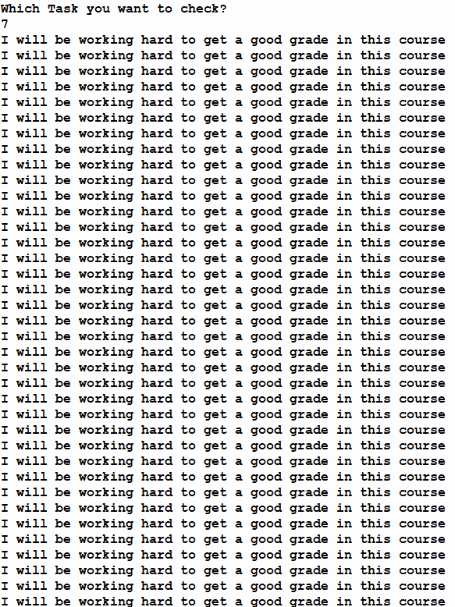

continued till 1000th times…..

8. Write a program using a loop that prompts a user to enter 5 integer values.

**Code:**

**void** task8() { *//prompts the user to enter 5 integer values*

**int** user;

**for** (**int** i = 0; i < REP; ++i) { *//repeats till i = (REP[const int] = 5)*

again:

cout << **"Enter only integer input: "**;

cin >> user; *//takes input from user*

**if** (cin.fail()) { *//determines that user entered valid input with regard to data type*

Beep(530, 700); *// 530 hertz for 700 milliseconds*

cout << **"Invalid Input, Try again"** << endl;

cin.clear(); *//will clear the error flag on cin*

cin.ignore(256, **'\n'**); *//will ignore any string if given in cin*

**goto** again; *//directs the program to "again" label*

}

}

cout << **"Task Accomplished. Five integer values have been taken from you."** << endl;

}

Output:

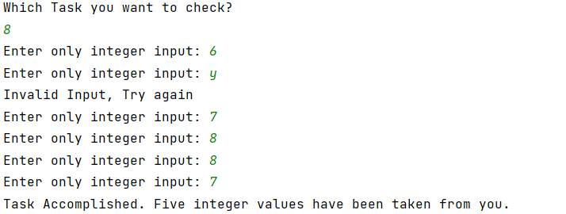

9. Modify your code of task 8 and store input values in an array.

Code:

**void** task9() { *//modification in task8 to prompts the user to enter 5 integer values and save it in array*

**int** user[REP];

**for** (**int** i = 0; i < REP; ++i) { *//repeats till i = (REP[const int] = 5)*

again:

cout << **"Enter only integer input: "**;

cin >> user[i]; *//takes input from user*

**if** (cin.fail()) { *//determines that user entered valid input with regard to datatype*

Beep(530, 700); *// 530 hertz for 700 milliseconds*

cout << **"Invalid Input, Try again"** << endl;

cin.clear(); *//will clear the error flag on cin*

cin.ignore(256, **'\n'**); *//will ignore any string if given in cin*

**goto** again; *//directs the program to "again" label*

}

}

cout << **"Task Accomplished. Five integer values have been taken from you and stored in an array."** << endl;

}

Output:

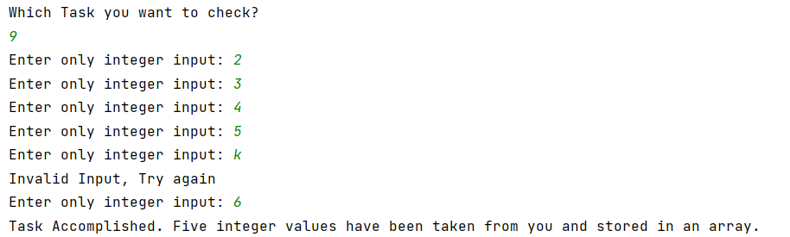

10. You are given the following data:

11 12 13

21 22 23

31 32 33

How will you store this data? Write code to store it and print on console.

Code:

**void** task10() {

**int** arr[ROWS][COLS], start = 0;

**for** (**int** i = 0; i < ROWS; ++i) {

start += 10;

**int** increment = start;

**for** (**int** j = 0; j < COLS; ++j) {

increment++;

arr[i][j] = increment;

}

}

cout << **"Output: "** << endl;

**for** (**int** i = 0; i < ROWS; ++i) {

**for** (**int** j = 0; j < COLS; ++j) {

cout << arr[i][j] << **" "**;

}

cout << endl;

}

}

Output:

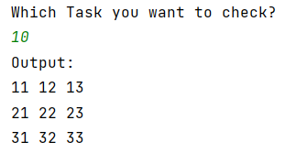

—-----------------------------------THE END------------------------------------------